

**PRESS RELEASE** Prague, 26th October 2015

# A New Public Park for BB Centrum – Brumlovka Park

**BB Centrum has grown with the addition of another green space – Brumlovka Park. The dominant feature of Phase 1, which is spread out over an area of 6500 m2 and includes expansive grassy areas with trees, bushes and benches, is the modern playground with many features. Here visitors will find a place to relax, have a picnic, or take a pleasant walk, and families with children will surely appreciate all the attractions for entertaining children and for developing their perception and motor skills. Brumlovka Park is easily accessible by public transportation and by foot from the Budějovická and Kačerov metro stations.**

The dominant feature of Brumlovka Park is the generously conceived playground with two pyramid towers connected by a tunnel, from which there is access to various types of slides. Children can have fun on several types of swings and on the jumping disk. For smaller children there is a wooden house with a sandbox around it and a blackboard to draw on. Both children and their parents can test their perception and balance on the balance blocks or ball-bearing table. And for dog owners, there is a special dog park set aside where they can walk their pets.

Brumlovka Park is located next to the newly-completed DELTA building, which is the greenest building in the BB Centrum complex. It has spacious terraces with trees and bushes and its western side is bordered by a grassy zone with a stream that joins up with the new park.

“During the construction of BB Centrum, we are thinking not only about the companies for which we are creating facilities, but also about the people living in and around it. That is why we are trying to build green relaxation zones near the office buildings, which helps improve the living environment in Prague 4. At the same time we want to create a safe and attractive place for families with children, where they can go and spend time together in the fresh air,” said Vendula Malochová, Marketing Manager of PASSERINVEST GROUP, the developer and investor of the project.

PASSERINVEST GROUP invested CZK 11,500,000 in the construction of Phase 1 of Brumlovka Park, which it will continue to expand. In the next phase there are plans for a children’s traffic playground and a lake with a model of Solomon’s Temple. Just like the other public greenery in the BB Centrum complex, Brumlovka Park will be managed and maintained at the expense of PASSERINVEST GROUP.

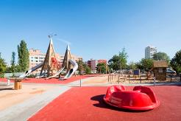

Brumlovka Park in BB Centrum

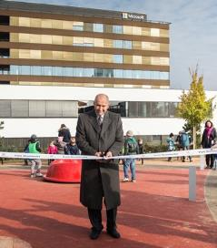

Radim Passer, Chairman of the Board of Directors of PASSERINVEST GROUP, opened Brumlovka Park

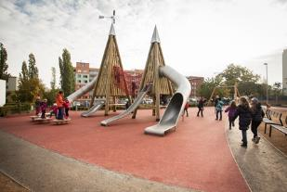

Modern playground in Brumlovka Park in BB Centrum

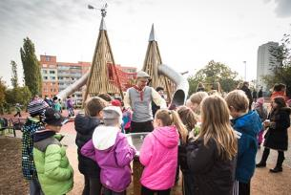

Children and clown performance at the opening of Brumlovka Park in BB Centrum

For more information and photographs in print quality please contact:

Mgr. Vendula Malochová**,** Marketing Manager

**PASSERINVEST GROUP, a.s.**

Tel.: (+420) 221 582 111, fax: (+420) 222 515 521

Mobil: (+420) 605 318 974

E-mail: [Vendula.Malochova@Passerinvest.cz](mailto:Vendula.Malochova@Passerinvest.cz)

www.passerinvest.cz, [www.bbcentrum.cz](http://www.bbcentrum.cz)

Ing. Marcela Štefcová

**Crest Communications a.s.**

Tel.: (+420) 222 927 125

Mobil: (+420) 731 613 669

E-mail: marcela.stefcova@crestcom.cz

**About the Developer**

**PASSERINVEST GROUP, a.s.,** founded in 1991 by Radim Passer, is a purely Czech development and investment company whose name is associated in particular with the **BB Centrum** multifunctional complex in Prague 4 - Michle. With this project, the most successful and extensive Czech project of its type, the company has built its excellent reputation both at home and at the international level. Contributing to this is not only the high quality of the projects completed to date, but also its high level of service, its sense of fair play, its positive relationship with the tenants and users of its buildings, and its sense of responsibility towards society and the environment. **PASSERINVEST GROUP**’sportfolioincludes other interesting development projects.